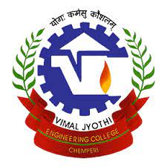 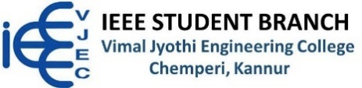 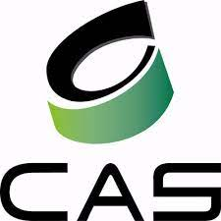 

**Membership Development Session**

* Venue: S1 ECE Class
* Date: 28/10/2022
* Total Number of participants: Around 50
* Number of IEEE Member: 04

**Brief:**

As a part of IEEE Circuits and System Society, a membership development and introduction session were conducted for the S1 ECE students on 28/10/2022.The session was the nitration between the students and the members. There were around 50 students along with 04 IEEE members. A good response was put forward by the students and they are eager to know more about this and wanted more sessions like this in future.

**EVENT POSTER: -**

